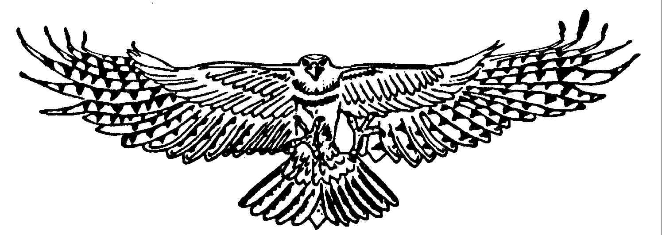

Adult One hour Handling Experience
Your experience will begin at The Raptor Centre, where we will provide you with a glove. You will receive simple instructions on how to handle the birds safely, from here on in; you will get the chance to hold a number of the birds on your glove. If there is a particular bird that you would like to handle, we will do our best to facilitate this, but please understand that some of our birds are not always comfortable with other people, and as much as this is your experience and we want you to enjoy it, our birds welfare does come first.
At certain times of the year, you may also get the chance to see any babies that we are rearing at the time of your visit.
You are encouraged to ask as many questions as you would like, no question is ever deemed ‘silly’, so please ask away and we will do our best to answer them. You are more than welcome to take photographs as well.

When do the Handling Experiences run?
April to October inclusive - Every day except Wednesdays and Bank Holiday weekends.
November to March inclusive – Every day except Tuesdays, Wednesdays, and Christmas Eve, Christmas Day, New Years Eve and New Years Day.

What are the start and finish times?
There are two choices of start times:
11:00 – 12:00
14:00 – 15:00

What do I need to bring?
You don’t need to bring anything, although some people like to bring a camera to take pictures, and we’ve even had people bring a small notebook and pen to write down the name and species of birds they held.

What should I wear?
We ask that you wear neutral colours, such as blues, greens, browns, beige, black etc. Please ensure that you do not wear any brightly coloured clothing. We appreciate that it may be hot, and some people like to wear hats, most of our birds do not like them, so when handling the birds, we may ask you to temporarily remove it. We recommend flat comfortable shoes, as you will spend most of the experience on your feet.

Is there a minimum and maximum age limit?
The minimum age limit is 18 years old, there is no maximum.

Anything else?
Yes, your experience is one to one; there is no group (unless you have booked it that way), nobody else sharing your day, this means that we can take everything at your pace.

Any health issues that may affect the client’s ability to take part should have been disclosed before booking – If you have received this as a gift, it is now your responsibility to disclose any potential problems due to health.

Please Email us a contact telephone number.

Observers are required to pay full Hobbledown admission. Once the experience finishes, you will have the opportunity to spend up to 2 hours wandering around the site to see the other animals and use the café.

For general visiting, please be advised that Hobbledown is a family attraction, and therefore does not admit adults unless they are accompanied by children. This does not apply for your experience with us.

The Raptor Centre is based within the grounds of Hobbledown, their postcode is KT19 8PT

In the meantime, should you have any questions please don’t hesitate to get in touch with us – raptors@btconnect.com

We look forward to meeting you.

Kindest Regards,

The Raptor Centre

