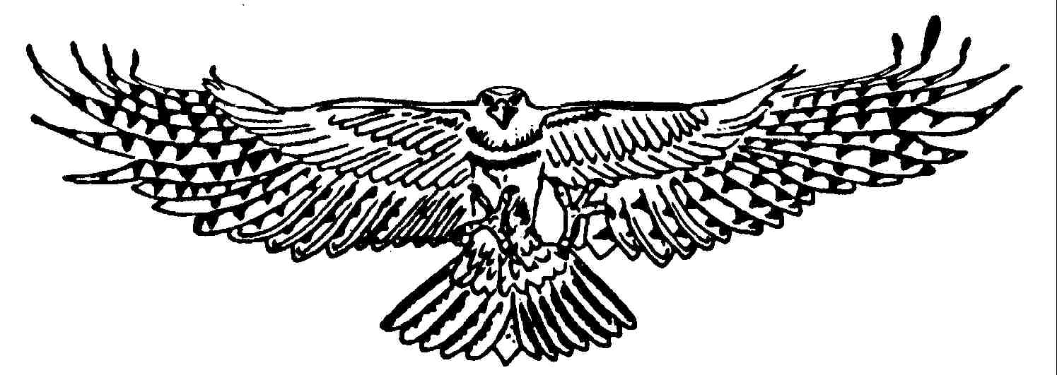

Adult One hour Flying Experience

Your experience will begin at The Raptor Centre, where we will provide you with a glove. You will receive simple instructions on how to handle the birds safely, from here on in; you will get the chance to fly up to five Birds of Prey. The birds that you will have the opportunity to fly include our Red Backed Hawks, Jackal Buzzard, Barn Owl and Indian Eagle Owl.
You are encouraged to ask as many questions as you would like, no question is ever deemed ‘silly’, so please ask away and we will do our best to answer them. You are more than welcome to take photographs as well.

When do the Flying Experiences run?
They run every day during our open season, except Bank Holiday weekends.

What are the start and finish times?
There are two choices of start times:
14:00 – 15:00
17:00 – 18:00 (during BST – British Summer Time Only)

What do I need to bring?
You don’t need to bring anything, although some people like to bring a camera to take pictures, and we’ve even had people bring a small notebook and pen to write down the name and species of birds they flew.

What should I wear?
We ask that you wear natural colours, such as blacks, greens, browns, beige etc. Please ensure that you do not wear any brightly coloured clothing. We appreciate that it may be hot, and some people like to wear hats, most of our birds do not like them, so when working the birds, we may ask you to temporarily remove it. We recommend flat comfortable shoes, as you will spend the experience on your feet.

Is there a minimum and maximum age limit?
The minimum age limit is 18 years old, there is no maximum.

Anything else?
Yes, your experience is one to one; there is no group (unless you have booked it that way), nobody else sharing your day, this means that we can take everything at your pace.

Any health issues that may affect the client’s ability to take part should have been disclosed before booking – If you have received this as a gift, it is now your responsibility to disclose any potential problems due to health.

Please Email us a contact telephone number – Flying Experiences do not run in the rain, and we may need to contact you if the weather looks unsuitable.

Observers are required to pay full Hobbledown admission. Once the experience finishes, you will have the opportunity to spend up to 2 hours wandering around the site to see the other animals and use the café.

For general visiting, please be advised that Hobbledown is a family attraction, and therefore does not admit adults unless they are accompanied by children. This does not apply for your experience with us.

Where are we?
The Raptor Centre is based within the grounds of ‘Hobbledown’.
Our address is
The Raptor Centre,
c/o Hobbledown,
Horton Lane,
Horton,
Surrey,
KT19 8PT

Finally, take it easy!
We pride ourselves on being flexible, if you have any problems, then please don’t hesitate to contact us, and we will do our best to accommodate any issues.

